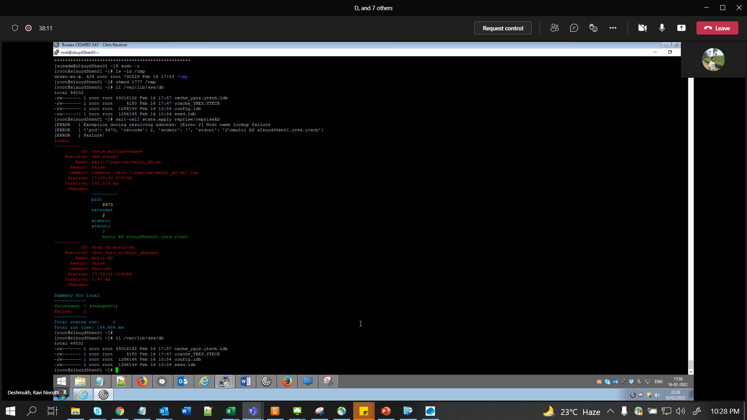

Tmp permission – 777

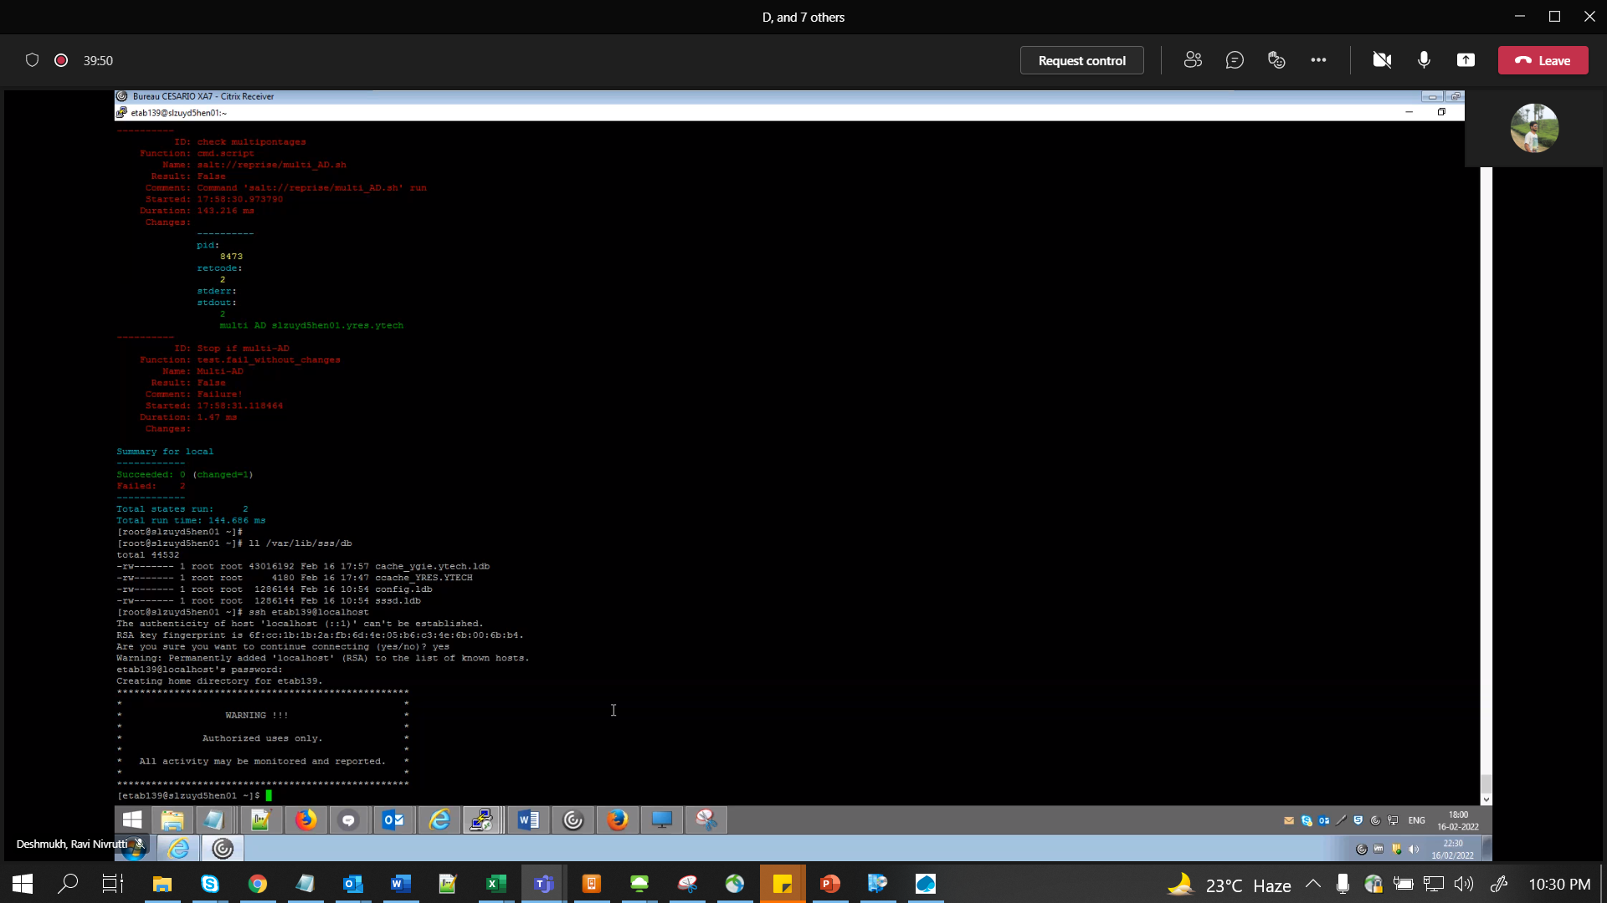

Even after reprise if its not connecting (try to connect locally wit hur ETA id), remove cache files

Cache files in /var/lib/sss/db – delete or move to /root, restart sssd

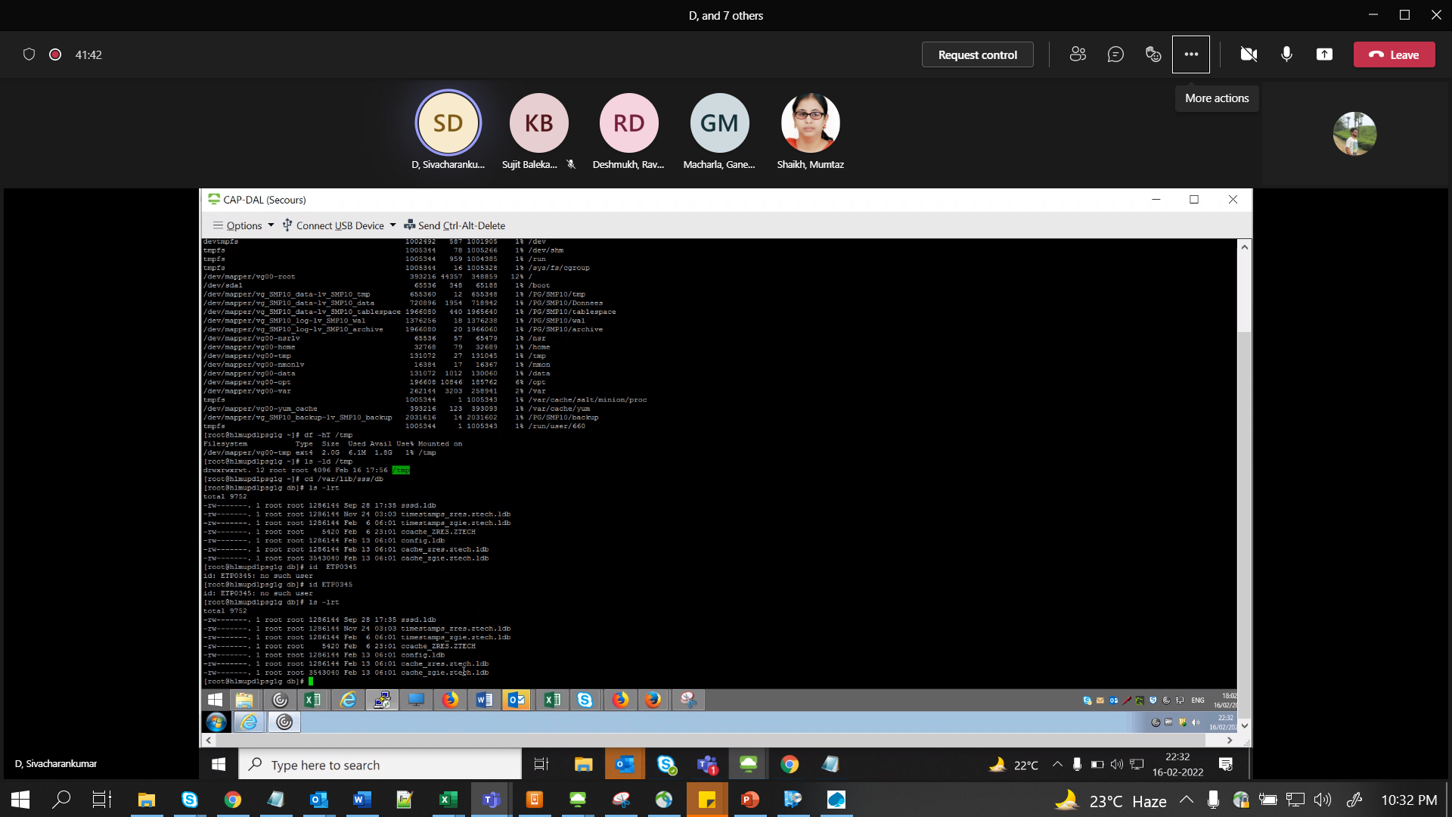

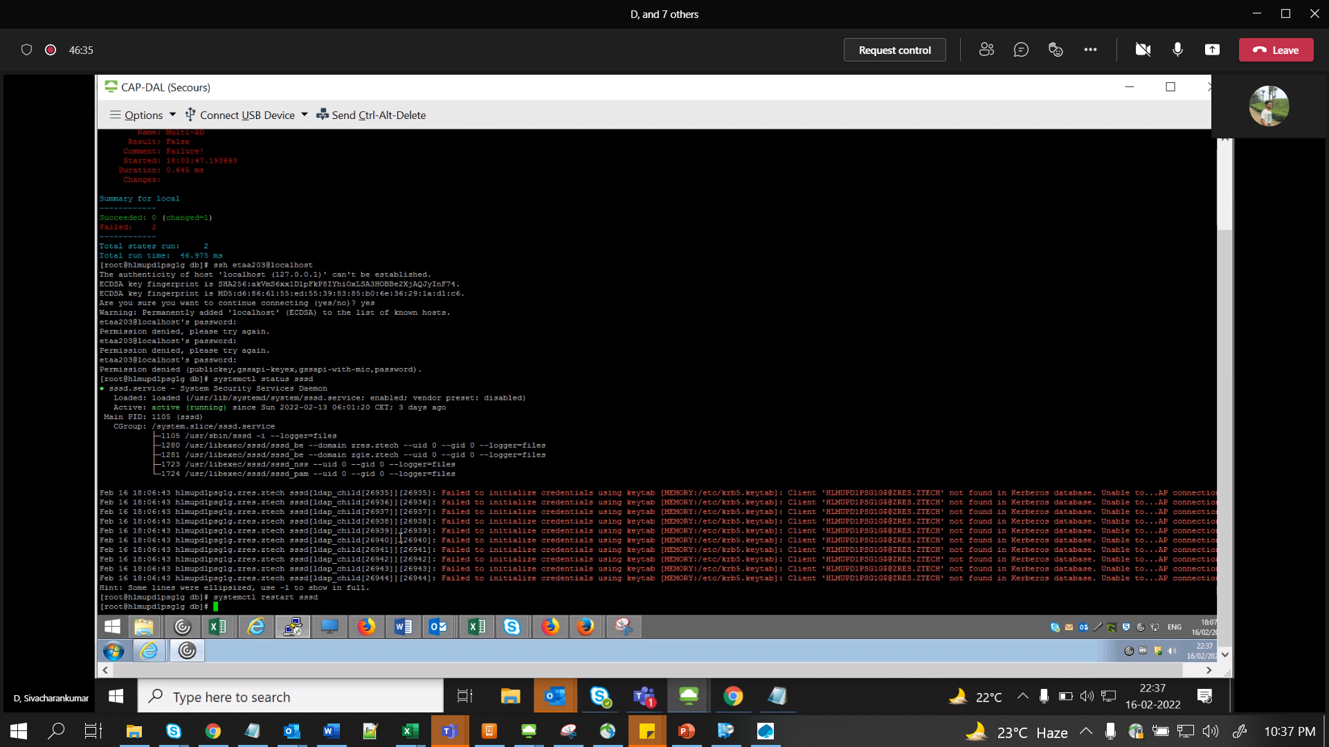

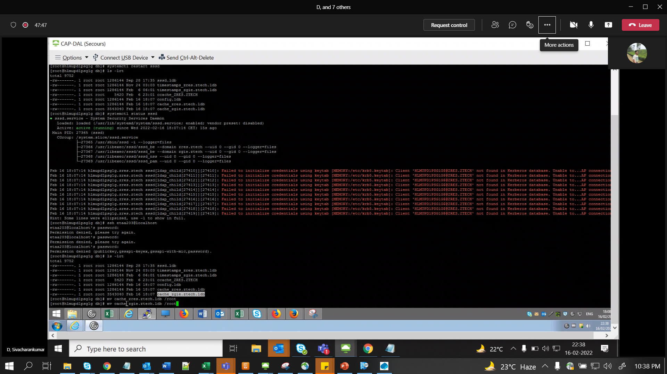

/etc/krb5.conf

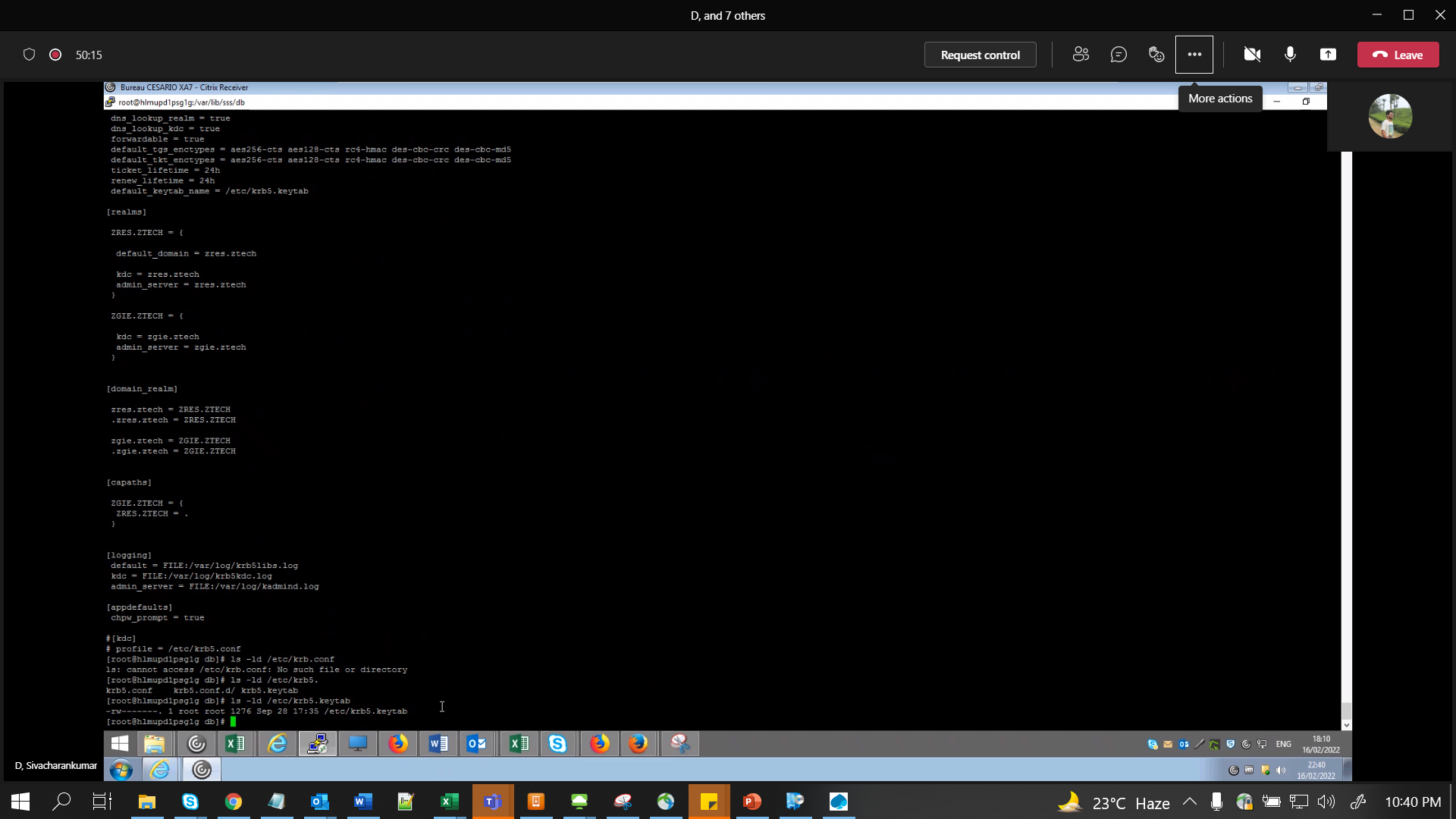krb5.keytab too